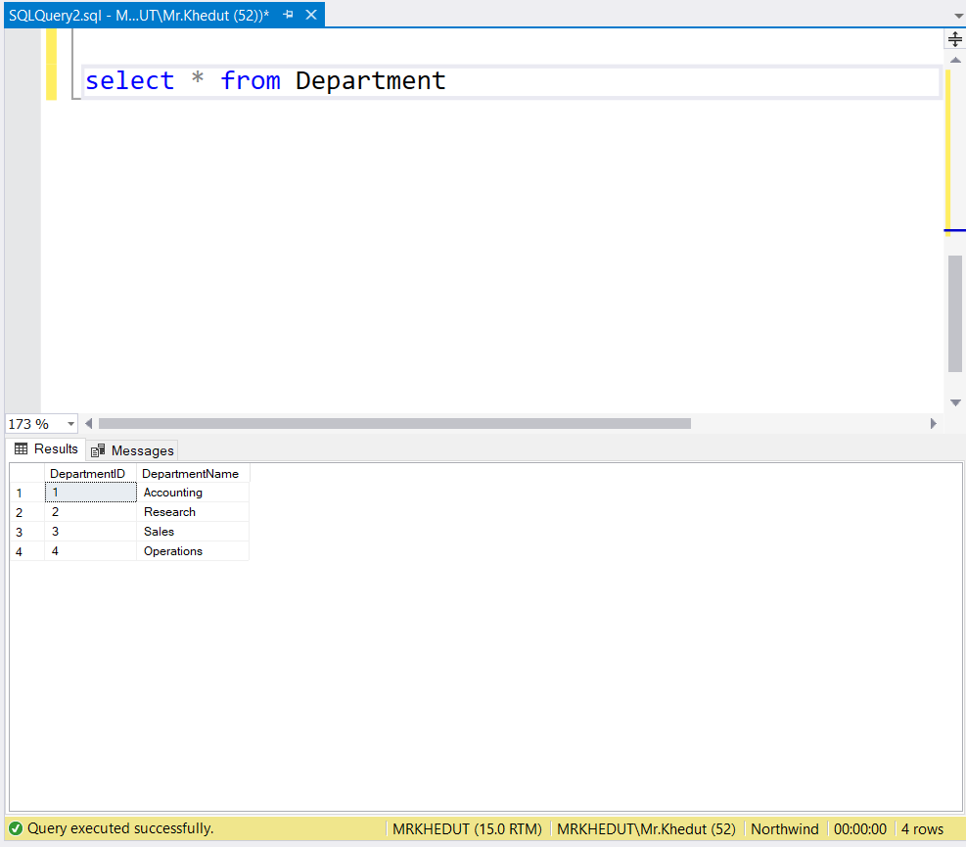

1. **write a SQL query to find Employees who have the biggest salary in their Department**

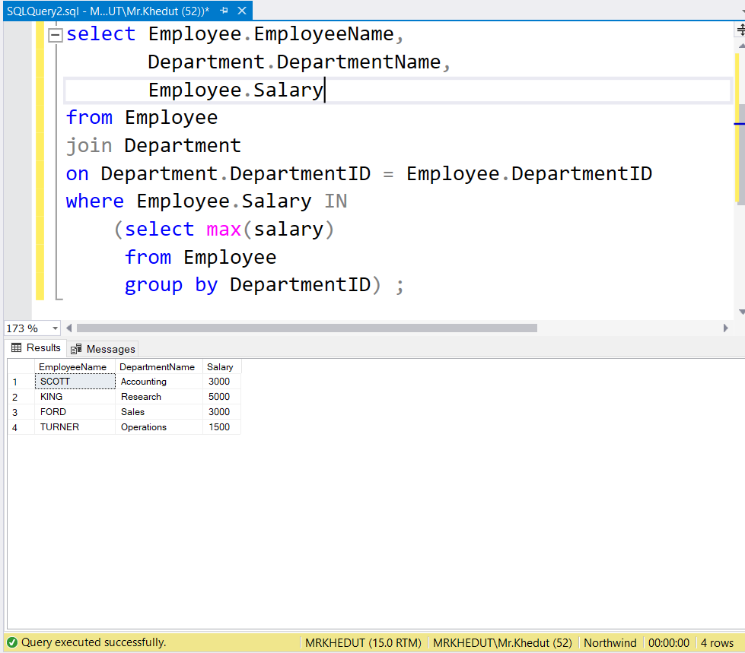

1. **write a SQL query to find Departments that have less than 3 people in it**

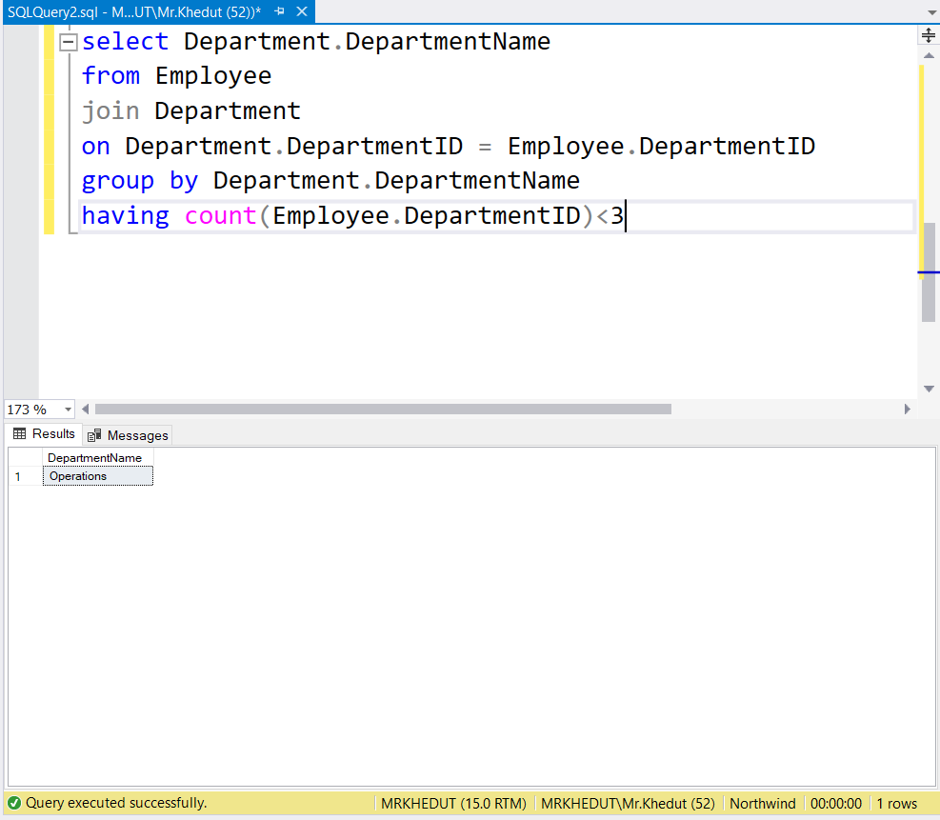

1. **write a SQL query to find All Department along with the number of people there**

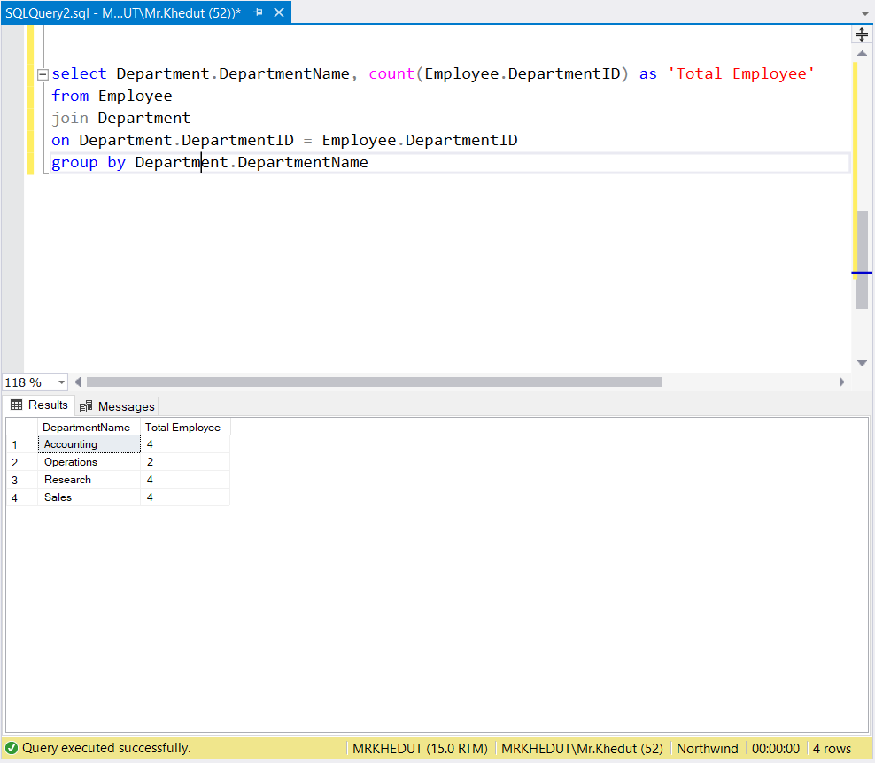

1. **write a SQL query to find All Department along with the total salary there**

